Project Design Phase-II
Data Flow Diagram & User Stories

Date | 09 September 2026
Team ID | SWUID2026190415
Project Name | Medical Diagnosis Center by Service Portal (ServiceNow)
Maximum Marks | 4 Marks

Data Flow Diagrams:
The Data Flow Diagram (DFD) shows how information moves through the Medical Diagnosis Center ServiceNow application. It explains how patient information enters the Service Portal, how appointments are processed, how reports are generated, and how payment information is stored.
DFD Level-0 Explanation
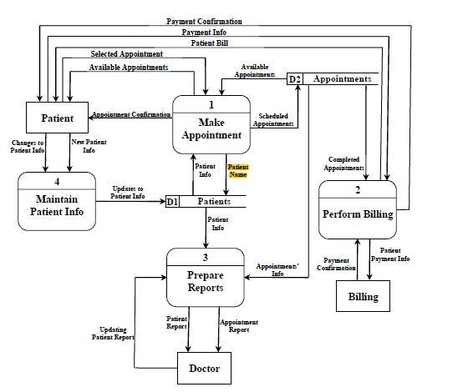
DFD Component | Project Explanation
Patient | Registers in the Service Portal and submits appointment details.
Service Portal | Receives patient details and sends booking requests to the system.
Appointment Management | Checks available slots and creates appointments.
Diagnostic Test Database | Stores available tests, prices, and categories.
Lab Technician | Updates sample collection and processing status.
Report Management | Uploads completed reports for patients.
Payment Management | Stores payment status and invoice details.
Administrator | Monitors appointments, reports, payments, and users.

User Stories
Use the below template to list all the user stories for the product.
User Type | Functional Requirement (Epic) | User Story Number | User Story / Task | Acceptance criteria | Priority | Release
Patient | Registration | USN-1 | As a patient, I can register in the Medical Diagnosis Center portal using my personal details. | Patient account is created successfully. | High | Sprint-1
Patient | Email Verification | USN-2 | As a patient, I receive a confirmation email after registration. | Confirmation email is sent successfully. | High | Sprint-1
Patient | Login | USN-3 | As a patient, I can log in using my email and password. | Patient accesses the Service Portal dashboard. | High | Sprint-1
Patient | Diagnostic Test Booking | USN-4 | As a user, I can register for the application through Gmail | Appointment is created successfully. | High | Sprint-1
Patient | Slot Selection | USN-5 | As a user, I can log into the application by entering email & password | Only available slots are displayed. | High | Sprint-1
Patient | Appointment Tracking | USN-6 | As a patient, I can view the status of my booked appointment. | Status changes are visible in real time. | High | Sprint-2
Patient | Report Download | USN-7 | As a patient, I can download my completed diagnostic report. | Report is available after completion. | High | Sprint-2
Patient | Payment | USN-8 | As a patient, I can make online payment for diagnostic tests. | Payment status is updated  as Paid/Pending/Failed. | Medium | Sprint-2
Receptionist | Appointment Management | USN-9 | As a receptionist, I can manage patient appointments. | Appointments can be viewed and updated. | High | Sprint-2
Lab Technician | Sample Collection | USN-10 | As a lab technician, I can update sample collection status. | Status changes to Sample Collected. | High | Sprint-2
Lab Technician | Report Processing | USN-11 | As a lab technician, I can upload diagnostic reports. | Reports become available to patients. | High | Sprint-2
Lab Manager | Approval Workflow | USN-12 | As a lab manager, I can approve specialized diagnostic tests. | Approval status changes to Approved or Rejected. | Medium | Sprint-2
Administrator | User Management | USN-13 | As an administrator, I can manage users and roles. | Users receive role-based access. | High | Sprint-3
Administrator | Dashboard & Reports | USN-14 | As an administrator, I can monitor appointments, reports, and payments. | Dashboard displays real-time data. | High | Sprint-3
Administrator | Email Notifications | USN-15 | As an administrator, I can configure automated email notifications. | Patients receive booking, payment, and report emails. | Medium | Sprint-3

